I saw a big need’

Elks leader continues group’s tradition of service

**By EVE NEWMAN**

[even@laramieboomerang.com](mailto:even@laramieboomerang.com)

Almost 600 people were expected to gather at the Elks Lodge in downtown Laramie on Christmas day to share a free meal.

The Community Christmas Dinner was in the works for weeks, and already multiple waves of volunteers have been making preparations at the Lodge, 103 S. Second.

Dennis Craig, the lodge’s Exalted Ruler, said the event is an opportunity to serve the community.

“There’s a lot of people that just don’t have the opportunity or funds or resources to fix a Christmas dinner,” he said. “That’s what it’s designed for. We get people that get the whole family together to enjoy the dinner.”

For Craig and other volunteers, enjoyment comes from serving others.

“It’s so satisfying to see the people that need it coming in, and being able to do that for them,” he said.

Craig is serving a one year term as Exalted Ruler, which is the Elks way of saying he’s the lodge president.

The Benevolent and Protective Order of Elks is a community-focused service organization that dates back to the Civil*War.*

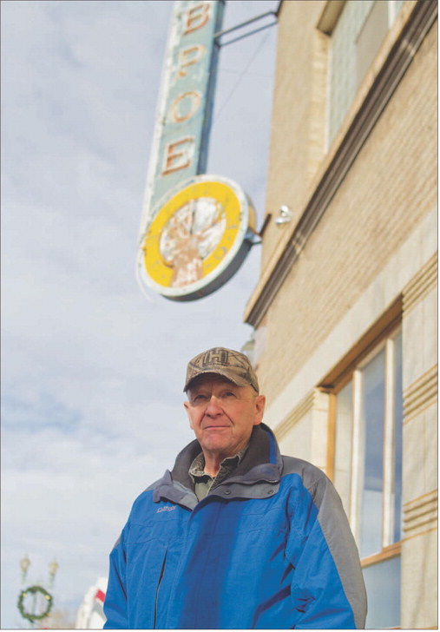

**Elks Club Exalted Ruler Dennis Craig stands outside of the lodge Dec. 18.** SHANNON BRODERICK/Boomerang photographer

 Founded in 1868 and preparing for its 150th anniversary next year, the organization began as a social club that started taking on service projects. “They saw a need to help soldiers, wounded veterans and families that had lost relatives in the Civil War,” Craig said.

In Laramie, the Elks meet in a building they built more than 100 years ago. Five mounted bull elk preside over a ballroom sized upstairs meeting room. In the basement, an expansive dining room and kitchen allow the organization space for one of its largest events of the year on Christmas day.

In preparation for the Christmas dinner, volunteers prepared and transported 32 turkeys for roasting at the University of Wyoming and another dozen volunteers came in to prepare more food.

Crews also set up tables and decorated.

On Christmas, 20 more volunteers prepared food, served food and cleaned up after, while also delivering meals to about 150 homes around town.

“One year when the roads were closed, we served about 200 people in motels,” Craig said.

The club also has a focus on serving youth, and to that end it supports the Albany County School

District No. 1’s backpack program, buys gifts for children at Christmas and buys clothing for students in need.

Craig and his wife, Lana, have lived in Laramie for the last 30 years. He was born in Rawlins and retired as a First Sergeant with the Army National Guard after a 40-year career.

He joined the Elks Lodge when he noticed a need for volunteers. That’s the same reason he put his name in for the head position.

“I saw a big need for someone,” he said. “They needed somebody that’s a leader. I said no for quite a while, and then I decided I’d better do something.”

While it’s no small job to run an organization with about 600 members, Craig said he still finds time for hobbies such as bowling with his wife, hunting with his son and working on vehicles.

“I’m retired. I’m not supposed to be working,” he joked.

Kay Dalles, the lodge’s club manager, said Craig brings a military sense of structure to his position while caring about other people.

“He’s very fair.

Anybody can go to him with anything and he’ll try to sit down and listen and try to figure out what’s going on,” she said.

**Scott Maestas**

**Customer Service Rep**

**307-755-3316**

**Laramie Boomerang**